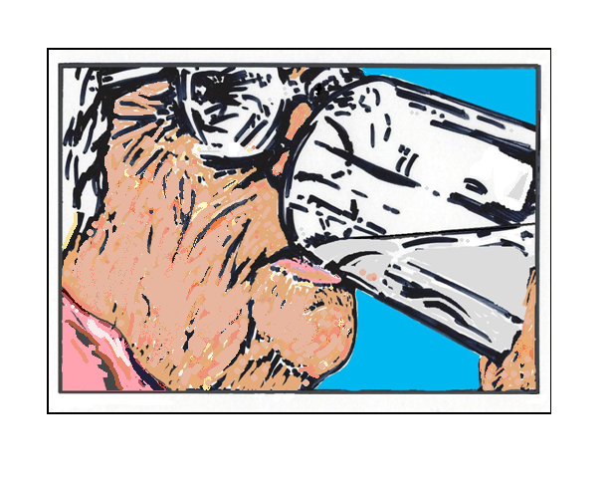

NO HYDRATION
NO LIFE

Information to protect
vulnerable patients from
involuntary euthanasia

Vulnerable patients can be in danger at hospitals, hospices and care/nursing homes.
The LCP (Liverpool Care Pathway) was abolished in 2014 but feedback has shown that it’s still continuing under the guise of EOL (End-of-Life) [1]. The LCP was stopped because patients were judged as ‘dying’ when they were not dying. The hallmarks of the LCP include the following: patients made unnecessarily Nil By Mouth, sedated, having fluids withdrawn, having life-saving and prescription medicine stopped. Once they were judged as ‘dying’, subsequent decisions made would cause their death. This is involuntary euthanasia.
Although standard practice, End-of-Life pathways are not natural deaths.
It usually depends on the medical team treating the patient if they practise involuntary euthanasia. Involuntary euthanasia is illegal in the UK but hospitals, hospices and care homes nevertheless practise it. This could be due to an interpretation of the NICE Guidelines (National Institute for Health and Care Excellence). End-of-Life can mean any of the following: people judged as dying within 12 months; people with advanced, progressive, incurable conditions and people with life-threatening conditions.[2] Unfortunately this leaves room for poor judgment whereby a patient’s general frailty or old age might be considered, wrongly, as a reason to end their life. [3]

THINGS YOU SHOULD KNOW: Dehydration can set in very quickly. If a patient is not receiving enough fluid either orally, via drip (IV), or tube to the stomach, then they will die. (Subcutaneous fluids via a drip under the skin are generally only suitable as emergency treatment, not for long-term active treatment. If used, the needle must be placed in a different site every 24 hrs, else is prone to infection from build-up of fluid under the needle.)
A person needs at least two litres of fluid intake daily. Diabetics and men may need more than two litres; similarly if the patient has had excessive loose stools or urine loss.
Be aware of any machine which can contribute to dehydration e.g. a BiPAP or CPAP machines. Two litres of fluid daily is minimum if on a BiPAP or CPAP machine due to drying out effects.
Keep the patient hydrated regularly. It is never too late to hydrate: it can save someone from dying from dehydration even in the last minutes.
Fluid and food are now seen as ‘treatment’. So, if doctors tell you that treatment will be stopped for a patient, that could well mean stopping nutrition and fluid intake as well, [4] including assisted/artificial hydration and nutrition.
A doctor has the right to stop active treatment whenever they want, without informing the patient or their next-of-kin, so this could include stopping nutrition and fluid. This is due to the Mental Capacity Act, when staff are entitled to make decisions on behalf of the patient.
Power of Attorney (Healthcare) can be helpful to speak up for the patient. Make sure a copy of this is in the patient’s medical notes.
You might be told that it’s kinder for the patient to no longer have any more fluid as they have too much fluid in them already; also that more fluid will be bad for their kidneys, or heart etc. But withdrawing assisted hydration will end in death if the patient is unable to swallow liquids.
It is not uncommon for patients to have oedema (swelling from fluid retention) and yet still be dehydrated.[5] Fluid retention doesn’t necessarily mean the person is getting too much fluid - it may mean the fluid isn’t where the person needs it. This can occur in conditions such as diabetes, heat stroke, diarrhoea, vomiting and heart failure. Fluid retention isn’t necessarily a sign that someone is ‘dying’.

Dehydration and dying are not the same thing. Dehydration can and should be treated or else it will kill.
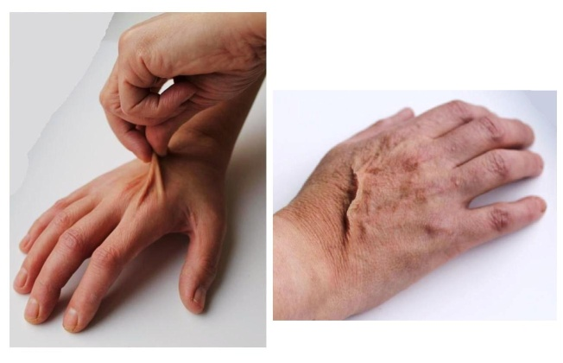

A good test is to gently lift a fold of skin on the back of the hand: if dehydrated, it will remain elevated. This is ‘skin ridging’ as seen in this image.
Signs of dehydration can be: thirst, confusion, dry mouth caked with thick material, drowsiness, slurred speech, vomiting, dark urine, burning of the bladder on urinating, unconsciousness.
Blood tests can help confirm dehydration if disputed. Ask for evidence if told the patient’s kidneys are struggling. High potassium levels are treatable.

Things you can do:

There is a phone number you can ring for advice and support if you feel a loved one is at immediate threat of euthanasia. Patients First Network via SPUC: 020 7091 7091
If you think your loved one is hungry or thirsty, and is conscious but can’t talk, show pictures for them to nod or point to e.g. food, drink (see pictures on back of this booklet or use other pictures).
If a patient genuinely has swallowing problems a nasogastric tube can be inserted; the tube might only be needed temporarily. A nasogastric tube does carry risks, so know about these beforehand.
The patient has a right to see their hospital notes, in line with the Data Protection Act 2018 and GDPR. If the patient is too unwell, consent for disclosure to a third party is lawful; this is usually the designated next-of-kin (name written in hospital records as NOK) who can then read the patient’s notes whilst still in hospital;[6] consent from the patient is needed in writing, so getting their written permission in advance for a NOK to read hospital notes is the better option. If the hospital team are uncooperative about this, request to see the Chief Executive or similar person of hospital authority.
Some information in the room may be read without permission, e.g. patient’s blood pressure, temperature and fluid chart but usually not the drug chart. It varies from hospital to hospital. Some are now changing from paper to electronic iPad medical notes but you still have a right to read them. Look for abbreviations such as NBM in the nutritional chart, on the wall or above/attached to head or foot of the bed; also check fluid amounts in the fluid chart. Is it enough fluid? Ask why a NBM order is there and for how long. This will reveal any intent to starve or dehydrate.[7] Ask what codes mean in the nursing drug chart. They might vary but in some hospitals a Figure 3 means NBM in the drug chart.
Ask for another doctor’s opinion, not necessarily from the same team. If not satisfied, consider transferring the patient to a private hospital. (Check first that you’re happy with the approach of a different hospital.)
Say what treatment the patient would or would not want. The Mental Capacity Act 2005 must go no further than doing what the patient would want if they had full capacity (case law 2013, Lady Hale). Take a look at the Patient Care Bill of rights, to fight for what the patient would want. https://dehydrationlifeline.org/ There are also free legal papers at this website.
Have the patient prepare a signed statement in advance for how they would or would not want to be treated (see Template Letter from https://www.thegracecharityforme.org/hazel-and-the-lcp/

THINGS TO BE CONCERNED ABOUT:
If the medical team tell you that the patient is dying, when you don’t believe that they are dying. If you are told that the patient’s body is ‘shutting down’.
If there is condescending talk of the patient’s ‘quality of life’.
If there is unnecessary interference with the patient’s oral food and fluid intake, e.g. either Nil By Mouth (NBM) or ‘swallowing problems’ when you don’t believe there are problems. Ask to see a swallowing assessment for a ‘safe swallow’ from a Speech & Language Therapist (SALT). If one hasn’t been done or if you are unconvinced by the assessment, then any oral intake restriction should be challenged.
If the patient isn’t speaking, with no convincing reason from the medical staff as to why. (They might be dehydrated or unnecessarily sedated.)
If sedatives or morphine/diamorphine have been written up, ask why? These drugs can decrease oxygen and can mask unpleasant symptoms of dehydration. Opiates and sedatives should not be combined, as stated in medical guidelines, yet they often are. (Check under the sheets to see if a syringe driver is attached to the patient; unless needed for severe pain, the drugs can also be used to hasten death.) https://bnf.nice.org.uk/drugs/midazolam/#contraIndications
Has the patient been issued with a Do Not Resuscitate Order (DNR/DNAR/DNACPR)? If so, ask why? It’s illegal for a DNR to be issued without prior consent from the patient or next-of-kin, yet this happens. DNRs can go beyond withholding resuscitation to also withholding fluids and active treatment. [8]
If things still don’t seem right to you as a next-of-kin, don’t be afraid to stand up for your relative. You may be their last line of defence.

Useful links

Dehydration LifeLine – Help for relatives of loved ones who are being denied fluids
www.dehydrationlifeline.org

www.prolifenurses.com

Book ‘The Good Samaritan Nurse in a Secular Age’, by Teresa Lynch Resources | Nurses Opposed to Euthanasia (prolifenurses.com)

http://www.thegracecharityforme.org./hazel-and-the-lcp/

Endnotes
[1] Statement by Carla Lockhart MP. See When ‘End of life Care’ Goes Wrong March 2023. A report by the Lords and Commons Family and Child protection Group When End-of-Life Care Goes Wrong – New Publication – Available Now! – Voice for Justice (vfjuk.org)

[2] www.nice.org.uk/guidance/qs13 updated March 2017
Also, Care of dying adults in the last days of life NICE December 2015 Recommendations | Care of dying adults in the last days of life | Guidance | NICE

[3] rockwood-frailty-scale_.pdf (england.nhs.uk)

[4] The Mental Capacity Act 2005 considers treatment as ‘any diagnostic or other procedure’; therefore assisted /artificial food and fluid falls into that definition. A patient over 16 yrs of age who is judged as lacking mental capacity (even temporarily) can have decisions made for them by medical staff. This is meant to be in the patient’s ‘best interests’ but is not always. You can only appoint a Power of Attorney (Healthcare) or make an Advance Decision if you are 18 or over.

[5] This occurred in the notes of patient Hazel Turner http://www.thegracecharityforme.org./hazel-and-the-lcp/
[6] The Medical Protection Society (Access to Health Records) https://healthplan.co.uk/blog/access-medical-record/

[7] Interview with Prof. Patrick Pullicino, Consultant Neurologist. Article pub. 23/7/16
http://www.dailymail.co.uk/news/article-3704954/Veteran-condemned-die-NHS-Doctors-leading-hospital-great-grandfather-chest-infection-notorious-death-pathway-wrongly-deciding-not-saved.html

[8) see publication Endnote 1, page 89

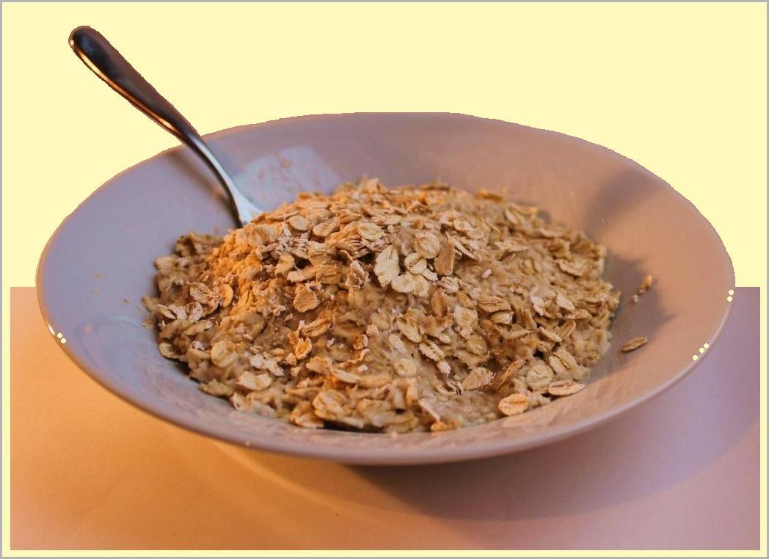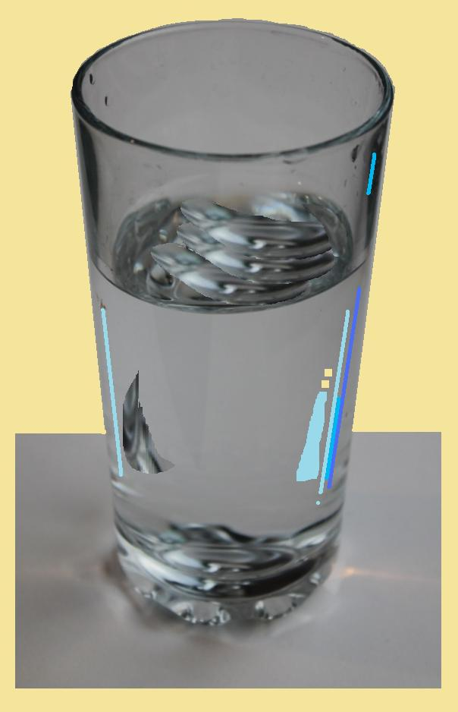
WATER
JUICE
OATMEAL

ICE CREAM
EGGS
BANANA

With grateful thanks to the doctors and nurses who contributed to this booklet

In memory of Hazel Turner
Produced by The Grace Charity for M.E. reg. 1117058 Copyright 2017, 2020, 2024
Permission given to freely distribute in any form provided sources acknowledged and content unchanged. Download from www.thegracecharityforme.org/hazel-and-the-lcp
Disclaimer: Although this information is intended to save lives, The Grace Charity for M.E. does not accept responsibility for negative outcomes linked to this booklet.

