INTRODUCTION
M.E. sufferers often have difficulties at the dentist’s due to the nature of their illness. This leaflet has been designed to help minimise these difficulties.
WHAT IS M.E.?
M.E. stands for Myalgic Encephalomyelitis. It is a disease of the Central Nervous System and has been classified as a neurological illness by the World Health Organisation since 1969 (Code ICD 10 G93.3).
DENTIST LOCATION
M.E. sufferers should take into account any stairs which may need to be accessed for treatment. Are they able to climb the stairs? How many steps etc.? Severe sufferers will not be able to climb stairs, so wheelchair access must be made available. For those who are able to climb stairs, they might not be well enough to come back down them, due to after-effects from the treatment. It’s probably a good idea to have an able bodied person accompanying the patient to the appointment.
PRACTICAL DIFFICULTIES
Hypersensitivity:

Sufferers will most likely find the bright lights distressing at the dentists, even if ordinary sunglasses are given to protect their eyes. They may need to consider bringing their own dark glasses, possibly wrap around, which block out UV (Ultra Violet) light; these can help with fluorescent lighting.
Even the radio might affect sufferers due to brain problems processing information. If possible, request that the radio be turned down or even turned off. Some may find that other noise distresses them, e.g. a drill, so may need to bring earplugs if tolerated.

Time of day:
Due to possible after-effects of treatment, combined with exhaustion, it may be better to see an M.E. patient at the end of the day, when no-one else is waiting to be seen after them.
Chemical sensitivities:
Sufferers can be extremely sensitive to chemicals used at the dentists. Ethanol (alcohol) can exacerbate their symptoms, even in small amounts, as can chemicals with adrenalin. Where possible, an adrenalin-free local anaesthetic should be used e.g. Citanest, to minimise side-effects. However, some patients have reported severe relapses from even non-adrenalin local anaesthetics, e.g. Mepivacaine (Scandonest 3% plain).
If the patient can’t use the mouthwash due to chemical sensitivities, they could always bring their own bottle of salt-water.
OTHER CONSIDERATIONS
Hydration:

M.E. sufferers should make sure that they are well hydrated before a trip to the dentist’s, especially if they are due to have treatment for a crown. This is because a dry mouth is needed for a crown fitting, so they may not be allowed to swallow water during this procedure.
Head position:
There is known hypo perfusion (low blood flow to the brain) with sufferers. Therefore excessive tilting of the head backwards and forwards can make the patient light headed and faint.
A few sufferers can have problems with swallowing, of either swallowing fluids or gagging on phlegm build-up which can be part of the illness (Care for Someone with Severe M.E. by Greg Crowhurst, p138 www.stonebird.co.uk ). A patient will know what they can tolerate, so it might be best for them to sip water in small quantities only, or to use a signal indicating they need a rest time.
REST PERIODS
Having the mouth open so wide for so long can cause unnatural exhaustion in sufferers. Some patients have found it helpful to have the mouth open for short periods of time, e.g. 10, 15 or 20 seconds and then close it. This way, sufficient rest periods for the facial muscles can be addressed.
FILLINGS
It has been reported that some sufferers have bad reactions to mercury fillings. The possibility of white (non mercury) rather than amalgam fillings may need to be discussed. These tend to be slightly more expensive. Please note that mercury fillings adversely affect only some sufferers. (See research papers on Mercury Toxicity by Bernard Windham, President & Research Director of DAMS International.)
M.E. sufferers may also be more susceptible to abscesses, especially after dental surgery, due to a poor immune system.
GAGGING
An excessive build-up of saliva in the throat which can impede swallowing may cause some problems. If the patient leans back too far, they can gag from saliva. A dry mouth can also contribute to gagging. Some helpful tips for patients might be:
- to breathe through their nose
- use a nasal decongestant before treatment (check ingredients due to chemical sensitivity, especially alcohol)
- put a little salt on the tongue
- if able to, hum during treatment (can’t gag whilst humming)
- to suppress the gag reflex by placing thumbs in the palms of hands and clenching fists, like the diagram:
(Some sufferers may be unable to do this technique due to muscle weakness.)

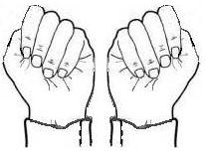

TRANSPORT
The St. John Ambulance can help with transport (including stretcher patients), wait for you and take you home again. General Enquiries: 08700 104950 Mon.-Fri. 9am-5pm. www.sja.org.uk
The Red Cross can also help with transport for medical appointments: General Enquiries 0844 871 11 11 www.redcross.org.uk
A charge is likely from both organisations but they should be cheaper than booking a private ambulance. The funding for it might even be met. This can be applied for by a dentist, or medical practitioner, filling in an ‘Individual Funding Request Application Form’.

HOME VISITS
For those patients who cannot visit a dental practice, the dentist might be able to come to them. The Community Dental Service exists to provide home dental visits for those unable to get to a dentist due to disability; they also have centres for the more vulnerable patient with particular needs. They can bring a full range of equipment to your home and even do teeth extractions. You will need a referral from your registered dentist; if you aren’t registered with one, your GP surgery should be able to help. Charges are the same for routine NHS costs. They also carry out private treatment.
Details: www.communitydentalservice.co.uk Tel: 01234 310223 info@cds-cic.nhs.uk
To find your nearest Community Dental Service you can also contact the local NHS England Area Team (type this into a search engine for results. If you’re unable to do this, phone the NHS on 111 with your query.)
NHS HELP WITH COSTS
An HC2 NHS Certificate is needed for those on low income to qualify for subsidised health costs. www.nhs.uk/healthcosts NHS Business Services Authority, Help With Health Costs, Bridge House, 152 Pilgrim Street, Newcastle NE1 6SN
Tel: 0300 330 1343

This leaflet has been produced by The Grace Charity for M.E. www.thegracecharityforme.org
with grateful thanks to members of
the 25% ME Group www.25megroup.org

Disclaimer: Although this information is intended to help M.E. sufferers, the Grace Charity for M.E. does not accept responsibility for adverse reactions due to the nature of the illness.

DENTAL LEAFLET
FOR M.E. SUFFERERS

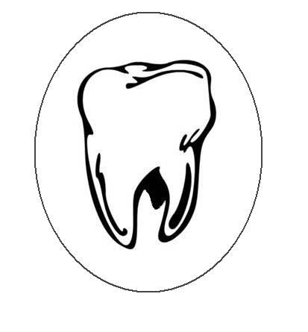

The Grace Charity for M.E.
20 Dickens Close
Langley
Maidstone, Kent
ME17 1TB

Registered Charity No. 1117058

Copyright 2016

