INFORMATION FOR PATIENTS AND HOSPITAL STAFF REGARDING TREATMENT OF PATIENTS WITH M.E.
(MYALGIC ENCEPHALOMYELITIS)

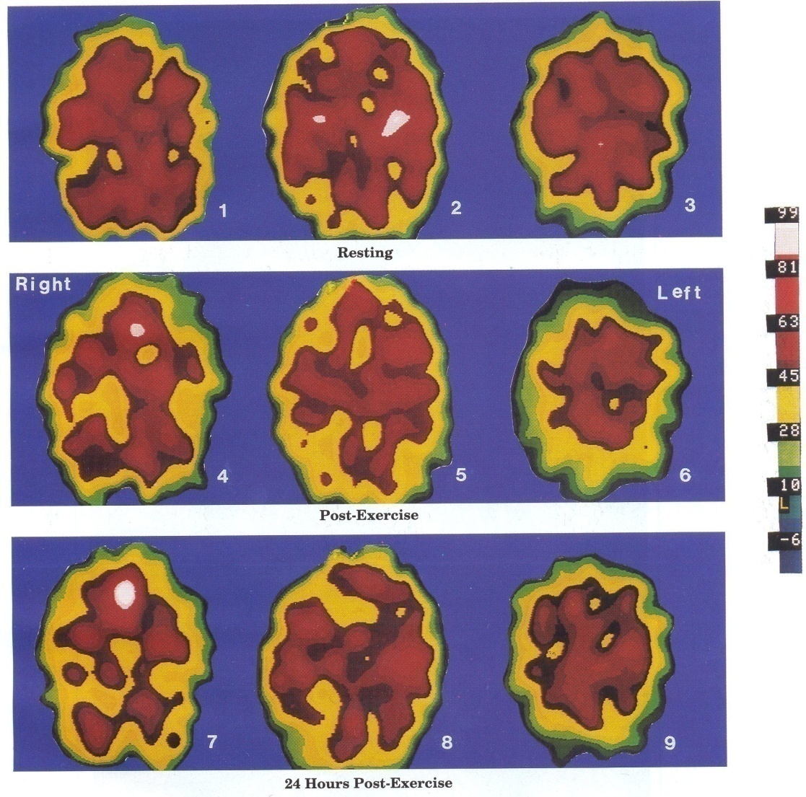
SPECT scans showing the negative effects of exercise
on an M.E. sufferer’s dysfunctional brain

Contents

- What is M.E.? What is CFS? page 3

- M.E. and hospital environments page 4

- Chemicals and drugs (including anaesthetics) page 6

- Surgery page 11

- Exercise and M.E. page 15

- Diet and allergies page 20

- References page 21

- Personal dietary and medication requirements page 25
list.

- Summary of the booklet page 26
Disclaimer. Whilst every effort has been made to check that the information in this booklet is correct, the Grace Charity for M.E. does not accept responsibility for any adverse reactions to treatment in this booklet should they be tried by M.E. patients. Whilst our aim is to help sufferers, any drug or chemical can potentially give a bad reaction to M.E. sufferers due to the nature of the disease.
More information regarding the SPECT scans on the front cover
can be found in the Exercise and M.E. section of this booklet.
What is M.E.?
M.E. is a neurological disease and stands for Myalgic Encephalomyelitis. It is an injury to the Central Nervous System, triggered by an infectious disease process, e.g. a virus. There is also evidence that M.E. symptoms are caused by chemicals over stimulating the immune system. It is a multi-system disease, affecting not only the neurological system but also the immune, endocrine, musculo-skeletal and cardiovascular systems.

Prognosis
Prognosis is varied depending on how much and which part of the brain has been damaged. Complete pre-illness recovery is rare but possible (around 6% of cases.) Some improvement, even marked improvement (different from full remission) is more likely than complete recovery, although relapses can occur several years after remission.Most cases stabilise at varying degrees of disability. Around 30% of cases are progressive and degenerative and degeneration of end organs may result in death. (One figure puts early M.E. death at 10%: this includes suicides. Pancreatic failure can also contribute to early death. A death rate of 2% has been recorded for cardiac pathology.)

What is CFS?
In this booklet, M.E. is sometimes referred to as CFS (Chronic Fatigue Syndrome), especially in the research papers and images. The name CFS was created in the 1980s with almost exclusive emphasis on the word ‘fatigue’, leaving out much pathology and previous physical M.E. research findings.

CFS may or may not mean the same disease as M.E. This is because there are currently at least 13 different interpretative criteria for CFS, some with an immune and others with a psychiatric specification. If the criteria used involves damage to the Central Nervous System, then it could well be M.E. If the criteria used focuses mainly on psychiatric fatigue, then this is not M.E.

M.E. has a long medical history of being a neurological disease, being classified in neurological textbooks since the 1960s (World Health Organisation classification of M.E. since 1969, see footnote 1; also, Lord Brain’s inclusion of M.E. in his book, Diseases of the Nervous System, Sixth Edition, Oxford University Press, 1962.) M.E. is a more specific name than CFS, implying the pathology which has been found. (See pathological research findings from Professor Anthony Komaroff and Dr. Byron Hyde from What is M.E? page from the Grace Charity for M.E. website:
https://www.th egracecharityforme.org/what-is-m-e/

M.E. and hospital environments
A hospital environment can be very distressing to M.E. patients as it can worsen their symptoms. Noise, light, sleep disruption and adverse reactions to chemicals and drugs can cause deterioration to the patient’s health. In fact, hospital should be the last resort for M.E. sufferers, faced only when home care and local surgery practice are insufficient for the patient’s needs. Some sufferers are concerned about hospital admittance if they have no family or contacts to be their advocates, as M.E. is so often misunderstood.

Noise and light problems
The neurological problems of hypersensitivity to noise and photophobia are due to sensory overload of the brain.
Practical remedies for noise hypersensitivity might be found from wearing earplugs or ear defenders. In addition, the patient will most likely need to be placed away from phones, television sets etc. Conversation and general busyness may tire the patient further.
Practical remedies for photophobia might be found from wearing dark glasses or night blinders (similar to those worn by airplane passengers). The patient may need to be placed away from excessive bright lights.

Sleep disturbance
Sleep is more essential to an M.E. sufferer than to a healthy person.
Hypersomnia is common in the acute stage of the disease but this can reverse to sleep onset difficulties in chronic M.E. Sleep problems are mostly due to the damaged brain stem and can result in restless painful legs and in some cases asphyxiation (from weak throat/chest/diaphragm muscles and poor oxygen blood levels). Two studies have shown a reversal of the sleep hormone melatonin, with too little melatonin at night and too much in the daytime. Over exhaustion can increase insomnia. Poor sleep can worsen many M.E. symptoms.
Practical remedies for sleep disturbance might be found under the previous remedies for noise and light. If these do not suffice, it might be necessary for the patient to be placed in a private room. Once the patient has finally got to sleep, try not to disturb unless necessary, due to sleep onset difficulties.

Concentration difficulties
These are universal in M.E. patients due to a neurological abnormality.
Practical remedies for concentration difficulties might include keeping noise and light to a minimum so the patient can save energy to concentrate. If asked extensive questions by staff, the patient may need breaks in order to rest in between the questions.

Chemicals and Drugs
“I had an horrific reaction to a drug my M.E. specialist prescribed for me five years ago and I have been bedbound ever since and very ill.”
(Quote from an M.E. sufferer in 2008 who contacted the Grace Charity for M.E.)

M.E. sufferers can be extremely sensitive to chemicals and drugs, due to abnormalities of the immune system. A worsening of M.E. symptoms may result from exposure to chemicals and drugs, with even the smell of an antiseptic wipe or the taste of ethanol from a cleaned thermometer affecting the patient.
Anaesthetics
There are several reasons why operations and anaesthetics can cause problems for people with M.E. Some of the main reasons are:
- Blood flow (perfusion) disturbances to the brain occur in M.E. This can be a concern as blood flow, along with oxygen to the brain, can be significantly reduced during an operation.
- M.E. sufferers frequently have problems with temperature control (thermoregulation) due to dysfunction of the hypothalamus gland.
- Drugs used for anaesthetics may act on brain chemical transmitter systems and neuromuscular transmission (nerve to muscle communication), both of which are already affected by M.E.

Local anaesthetics: Adrenaline in a local anaesthetic can worsen M.E. symptoms. Therefore, local anaesthetics should be adrenaline free. If Lignocaine (Lidocaine) must be used, it should be used sparingly and without adrenaline.
General anaesthetics: Surgery and general anaesthetics can cause serious worsening of M.E. symptoms. Anecdotal reports show that whilst some sufferers do recover from a general anaesthetic, albeit a slower recovery than a healthy person, others have become permanently seriously ill as a result of a general anaesthetic.
The following has been drawn up from suggestions by three M.E. specialist doctors (C.Lapp, E.Dowsett, P.Cheney) regarding recommendations for anaesthesia:
- Although Halothane is rarely used nowadays, hepatotoxic anaesthetic agents, including Halothane, should be avoided. (M.E. sufferers can re-activate latent herpes group viruses which may produce hepatitis.)
- Dr. Patrick Class suggests that anaesthesia for M.E. patients might include using Diprivan (Propofol) as the induction agent; Versed (Midazolam), fentanyl (a short-acting narcotic) and an anti-nausea agent during anaesthesia; a combination of nitrous oxide*(see following caution on nitrous oxide), oxygen and isoflurane (Forane) as the maintenance agent.
- Insure that serum magnesium and potassium levels are adequate.
(These can be low in sufferers. Depletion could lead to cardiac arrhythmias under anaesthesia.)
Dr. Cheney recommends the patient be given Micro-K using 10mE\q tablets, 1 tablet BID and magnesium sulphate 50% solution, 2cc IM, prior to surgery if indicated by preoperative testing.
- Hydrate the patient prior to surgery.
- Caution with drugs that lower blood pressure or stimulate neurogenic syncope (fainting), such as epinephrine (adrenalin), sympathomimetics, vasodilators and hypotensive agents. This is because of NMH (neurally mediated hypotension) frequently seen in M.E. patients, which can cause low plasma volume, low red blood cell mass, venous pooling and vasovagal syncope.
- Caution with histamine-releasing anaesthetics (including thiobarbituates e.g. sodium pentothal) and muscle-relaxing agents, avoiding them if possible.
- Use sedating drugs sparingly.
- Consider cortisol supplementation in patients who are seriously ill or who are chronically on steroid medications.
Dr. Charles Shepherd writes that a shorter-acting general anaesthetic might be advisable: this is sometimes used for patients with neurological disorders.
*Some anaesthetists may be unhappy in administering nitrous oxide to M.E. patients because those with chemical sensitivities may have problems with it. See following section on Multiple Chemical Sensitivity.

Muscle-relaxing drugs (including nerve blocks)
Although nerve blocks might be considered as an alternative to general anaesthetics, they can give severe side-effects especially with post-operative pain. Some sufferers have experienced violent shaking after nerve block injections. One sufferer has reported that the medicine gabapentin helped her with severe pain after nerve block surgery.
In addition, several M.E. specialist doctors advise caution with using muscle-relaxing drugs on sufferers due to potential adverse effects. Dowsett writes ‘The effect of muscle-relaxants in M.E., where muscles may be weak, wasted or otherwise damaged is much greater than in normal people.’ If muscle relaxants are unavoidable, start off with half the usual dose at onset with careful increments during the operation.(Some anaesthetists may find performing incremental doses of muscle relaxants to be unacceptable in practice.)
A ‘non-depolarising’ muscle relaxant may be preferable to a ‘depolarising’ muscle relaxant, to prevent potassium imbalance (as potassium levels can already be low in sufferers. See previous section under anaesthetics). M.E. patients, however, may still be extremely sensitive to a non-depolarising muscle relaxant. If possible, administer small doses in increments to test the ability of the muscles to contract during electrical stimulation. This testing can continue throughout surgery in order to determine the rate of recovery of the muscles from paralysis.(Once again, some anaesthetists may find performing incremental doses of muscle relaxants to be unacceptable in practice.)
Although the muscle relaxant suxamethonium can be a life saver, there have been anecdotal reports from the M.E. Association of sufferers feeling especially unwell after suxamethonium (also known as succinylcholine and celokurin ). This could be due to increased sensitivity to acetylcholine.
Both Lapp and Class recommend that those muscle-relaxants in the Curare family, including Tracrium and Mevacurium are best avoided if possible.
Dr. Sarah Myhill writes that anecdotal reports from some patients suggest that muscle relaxants can cause prolonged paralysis for hours after the anaesthetic, requiring ventilation. She also suggests that local anaesthetics (without adrenalin) should be used wherever possible, in preference to a general anaesthetic, including using a local anaesthetic as a pain blocker. When the total load of drugs is reduced, the idiosyncratic (unusual) reactions to drugs will be lessened for the M.E. patient.

Sedation
Although some patients benefit from antihistamine drugs due to high histamine release from allergy, anti-histamines can also cause problems for sufferers, as in most drugs.
Most M.E. patients are extremely sensitive to sedative medications, including benzodiazepines, antihistamines and psychotropics. These should be used sparingly and in small doses until the patient’s response can be assessed. A patient may have difficulty remaining in the same position for sedative procedures due to muscle weakness, which may be exacerbated by the drugs given.

Spinal Anaesthetics and Epidurals
These are debatable in medical opinion for M.E. sufferers. Some doctors believe that where there is neural involvement of disease, including M.E., an epidural or spinal anaesthetic is not to be recommended because of the risk of worsening symptoms. Others are of the opinion that epidurals and spinal anaesthetics might be more suitable for sufferers than general anaesthetics.

Multiple Chemical Sensitivity
M.E. sufferers may also have a condition known as Multiple Chemical Sensitivity (MCS). MCS is included in the World Health Organisation’s International Classification of Diseases ICD-10 under the code T 78.4. This code is for allergy.
Those M.E. patients suffering from severe MCS should avoid a gas anaesthetic (due to the neurotoxic effect on chemically sensitive patients).
If the patient is allergic to rubber, a disposable plastic mask for oxygen might be better.
Drugs containing preservatives or alcohol will most likely cause deterioration in the patient’s health. Where possible, use drugs which don’t contain alcohol or preservatives. Pre-prep solutions containing preservatives may exacerbate MCS symptoms.
During an operation, the body temperature should be maintained at a safe level because hypothermia is common for patients with sensitivities.
Strong cleaning solutions around the patient’s hospital bed might have to be replaced by the cleaning solutions of baking soda and water.
Some sufferers with MCS may be more sensitive to radiation from x-rays.
For more information on Multiple Chemical Sensitivity regarding anaesthetics, see www.anapsid.org/cnd/drugs
Also, for more information on MCS go to
www.mcs-international.org

N.B. M.E. and MCS are not the same disease. You can have one without the other or both. Most M.E. patients, though, are sensitive to chemicals.

Surgery
M.E. patients should only have surgery if absolutely necessary. This is because of sufferers often having adverse reactions to drugs and chemicals, being in a hospital environment and sometimes from the surgery itself.
Anecdotal reports suggest that some M.E. sufferers can tolerate surgery well, even major surgery, although they may need a longer recovery time compared to healthy patients. Some M.E. sufferers, though, have experienced permanent relapse from even minor surgery, whilst for others, surgery isn’t an option due to the severity of their illness.
For anaesthetics, drugs and chemicals in surgery please refer to the previous detailed chapter on Chemicals and Drugs.

Pre-assessment
It is important at the pre-assessment that the nurse is familiar with the information in this booklet. The patient may wish to mention possible concerns about fasting if they suffer from hypoglycaemia. Any herbal medications or supplements, etc. that a patient is taking, should be mentioned to medical staff before surgery, as the patient may be advised to stop taking them beforehand.
The patient’s respiratory function should be tested in advance of any operation as cerebral oxygen and oxygen delivery to the muscles is usually less than that of a healthy person.
In addition to all the above, the anaesthetist should also be made aware of a possible abnormal heart rate (studies have shown the heart rate of M.E. patients to be both elevated and reduced): also, of cautioning giving drugs that lower blood pressure (see previous chapter on Chemicals and Drugs). Patients should inform staff about their orthostatic problems, so as to avoid placing them in positions which might negatively affect their blood pressure and heart-rate both during and after surgery.
Respiratory functions of M.E. patients should be carefully monitored during surgery, along with cardiac function.

PHOTON EMISSION TOMOGRAPHY – PET SCAN
These PET scan images of a 34 year-old patient of Dr. Byron Hyde were provided by Dr. Stephen Lottenburg, University of California at Irvine. These images demonstrate significant mid-brain changes. This young lawyer has never returned to work during the past ten years after becoming brain disabled with CFS following an incapacitating viral infection. To date, the PET scan is the only brain imaging tool that has shown to demonstrate adequately sub-cortical physiological injury. (Quote from 1992.)

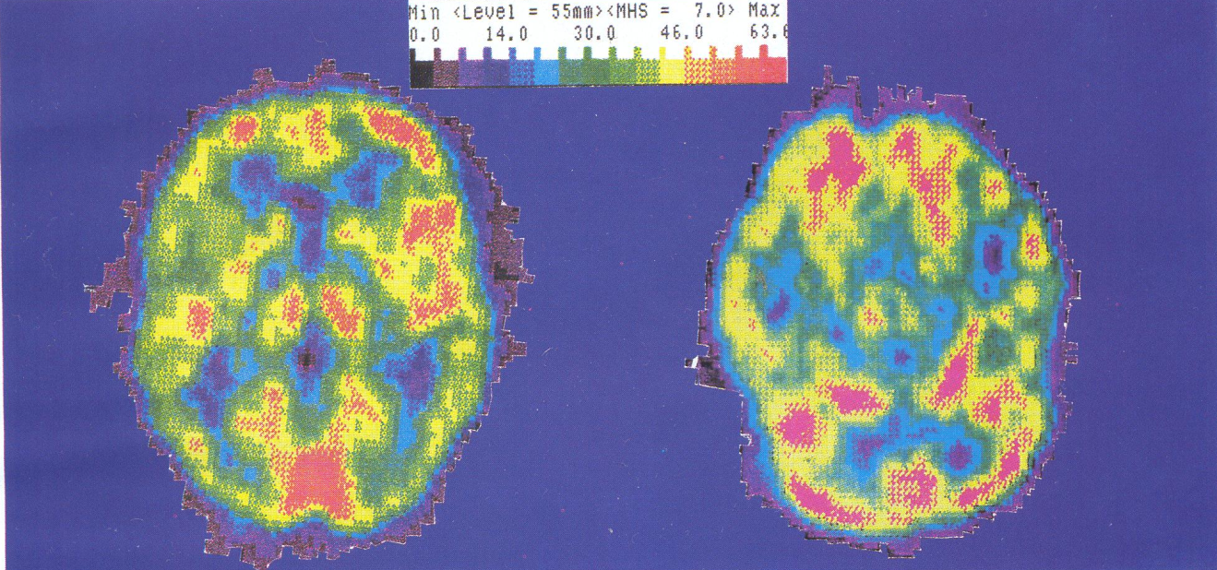

Figure 1
PET Scan, page v of Dr. Byron Hyde’s book The Clinical and Scientific Basis of Myalgic Encephalomyelitis/Chronic Fatigue Syndrome see Footnote 2 for book details.
Abnormal PET scans have revealed decreased glucose utilization (hypoglycaemia) in M.E. sufferers.

Preparing for an operation
Conserving as much energy as possible will help the patient. This can be achieved by resting in a noise-free environment, away from televisions, radios and background conversation. (These neurological symptoms are due to sensory overload of the brain, see ‘Noise and light problems’ in M.E. and hospital environments section.)
Research suggests a low circulating erythrocyte volume (approximately 70% of normal on average) but not plasma volume in M.E. patients. (Erythrocyte is also called Red Blood Cell.) Consequently, large amounts of blood taken all at once for tests may make a patient feel worse. Patients are advised to drink 1-2 glasses of water before blood tests, to help raise blood volume.
Being upright for too long can also make a patient feel unwell: if blood vessels go into spasm when inserting a needle or catheter, there might be more success if the M.E. patient lies down for these. For IVs (Intravenous medications), M.E. patients often benefit from small bore needles.

Fasting for an operation
Some M.E. sufferers may find this a problem as hypoglycaemia is common with this illness. Although a one off blood sugar test may reveal the blood sugar as adequate, this may fall suddenly an hour or two later. PET scans (Figure 1) can be used to detect decreased glucose utilization in sufferers.

Practical remedies for fasting
This is difficult as hypoglycaemia can be severe. The patient should try to eat complex carbohydrates e.g. bananas, pasta, wholemeal bread up until the time of fasting. Also, protein can slow down a reactive hypoglycaemic condition. Avoid simple sugars leading up to the operation. The supplement chromium can be helpful in treating reactive hypoglycaemia. For some patients, six hours is an impossible time to fast: for these patients, it is best they are the first on a morning list if they are due to have surgery, to prevent a hypoglycaemic coma.
Pain Sensitivity
Pain is very much a part of the illness M.E., with sufferers often experiencing very high pain levels indeed, even at rest. This is due to injury of the pain processing areas of the central nervous system as well as other immune dysregulations. Consequently, patients may need higher doses of pain medication for surgery compared to non sufferers.
M.E. patients are especially sensitive to sedative analgesic drugs, e.g. codeine and morphine due to their effects on the central nervous system.
In addition, M.E. sufferers can be extremely sensitive to touch, whereby the slightest pressure can bring excruciating pain. Some sufferers also have fibromyalgia and/or myofascial pain. (Fibromyalgia is a painful musculoskeletal disorder which exhibits tenderness at multiple points about the body.) Although some may be able to wear support stockings, for others pressure bearing appliances may cause an extreme pain reaction. Surgical stockings may be unbearable for some sufferers to wear. (M.E. patients often have poor distribution of blood volume. This can be due to both abnormally constricted and dilated blood vessels. Consequently, sufferers can have blood pooling in the legs, abdomen and hands. )
Blood pressure arm wraps, clips on fingers monitoring oxygen and the banging on a patients’ arm before the insertion of the anaesthetist’s needle might also be especially painful. The patient may also be unable to clench their fist very tightly for blood tests due to weak arm muscles. Practical remedies for decreasing pain may have to be thought out by hospital staff, using alternative methods which cause less pressure on the muscles. (A help for blood tests might be to place a warm hot water bottle on the M.E. patient’s arm to increase vein blood flow, if the patient can tolerate the pressure of the bottle.)
Post-operative Care
An M.E. patient will take longer than usual to recover from an operation. They may also need additional support at home and perhaps more care from the community nursing services than the average patient requires. Due to extra post-operative care, arrangements will need to be planned well before hospital admission.
Exercise and M.E.

‘After activity, the recovery of muscle power is slower than in any other disease.’

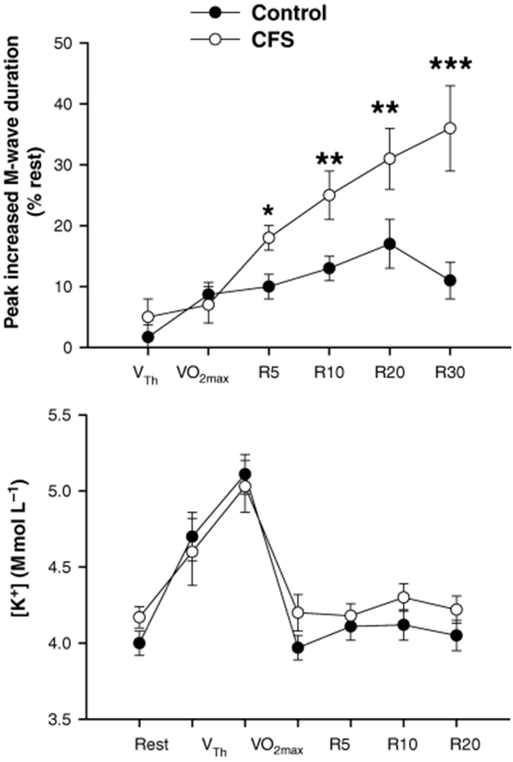

Figure 2
This chart demonstrates that M.E. sufferers (CFS) produce high levels of oxidative stress (isoprostanes, i.e. highly TOXIC by-products of abnormal cell membrane metabolism) from increased exercise, compared to healthy controls.

SPECT SCANS
These Xenon SPECT scans of a 37 year-old female M.E./CFS patient and their concept were provided by Dr. Jay Goldstein of Anaheim, California. The technical expertise is that of Dr. Ismael Mena, UCLA Harbor, California.
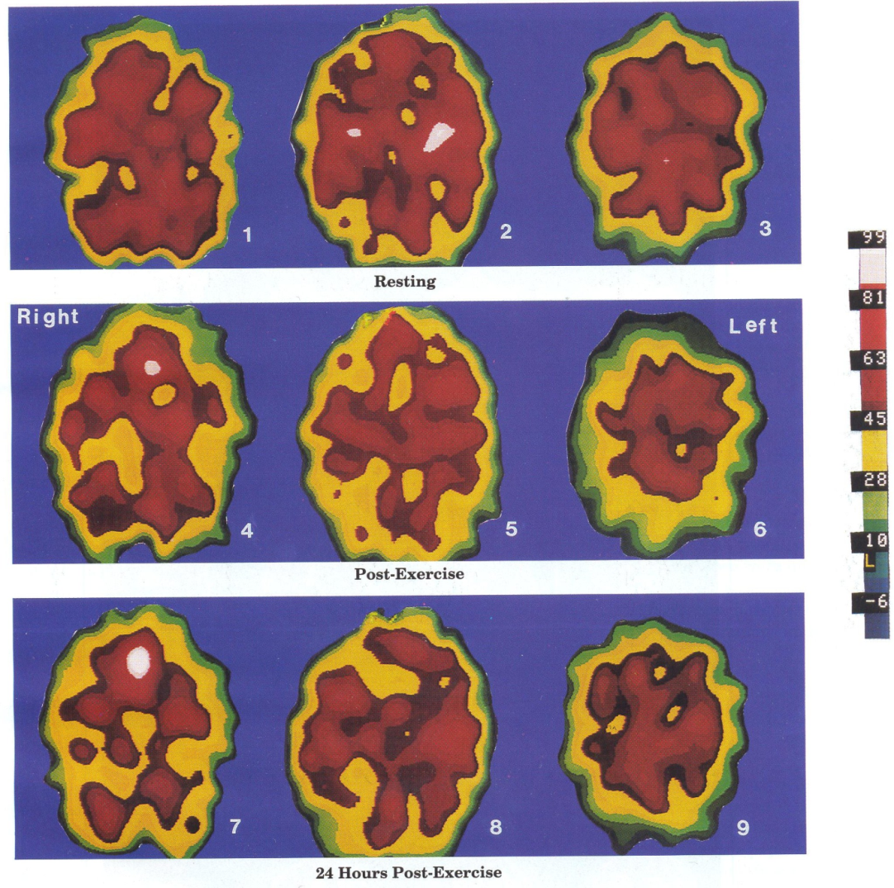

Figure 3
SPECT scans, page vii of Dr.Byron Hyde’s book The Clinical and Scientific Basis of Myalgic Encephalomyelitis/Chronic Fatigue Syndrome. See footnote 2 for further book details. Below is a summary of the corresponding text.

Images 1, 2 and 3 represent the abnormal resting state of an M.E./CFS brain, with perfusion defect (poor blood flow).

Images 4, 5 and 6 represent a further decrease in perfusion immediately after exercise.

Images 7, 8 and 9 illustrate the severely decreased brain perfusion of the same patient 24 hours after physical exercise.

Similar brain perfusion could be produced in an M.E./CFS patient as a result of sleep deprivation, a secondary infectious state, cognitive, sensory or emotional factors. A normal healthy patient will probably exhibit increased brain perfusion after similar modest exercise.
Muscles and M.E.
Science has shown that the mitochondria (energy producing part of the muscle) has abnormal functioning in M.E. In fact, the worsening of symptoms after exertion is a principal clinical diagnosis of M.E. Raised levels of toxins from abnormal cell membrane metabolism, after exercise, has been discovered. In addition, SPECT scans have shown that the brain can be badly affected after exercise, affecting speech, thinking processes and other brain function (see Figure 3). Further findings have demonstrated persistent muscle infection in some patients.
Post-exertional malaise is a classic symptom of M.E. when the patient has a knock-on effect 24 hours or several days after exercise. The brain is affected much more later on, compared to the moment when the exercise was performed (see Figure 3).
After surgery, an M.E. patient’s muscles could well be weaker than before they went into surgery, with possible temporary paralysis, due to the use of drugs and chemicals which can worsen their symptoms.

Physiotherapy and Post Surgery Exercise
An M.E. patient WILL NOT usually be able to do the physiotherapy exercises normally prescribed for post-surgery. In addition, they won’t be able to ‘get moving’ on their own strength and may find shuffling along the bed to assist nurses to be impossible. M.E. is primarily an illness affecting the muscles and brain with patients having HIGH RESTING ENERGY REQUIREMENTS which diminish their resources. In addition, patients can experience shallow breathing and shortness of breath as an ongoing illness symptom which can be exacerbated by exercise.

If chest infections and pneumonia are a risk, the patient may need assistance with sitting up and moving around, in order to avoid these. However, keep in mind that forcing muscles could cause a relapse; also, Orthostatic Intolerance (the inability to sustain upright activity), with or without tachycardia, is common in M.E. sufferers, which can cause faintness.

Response to Exercise | Healthy People | ME/CFS Patients
Sense of well-being | Invigorating, anti-depressant effect | Feel malaise, fatigue and worsening of symptoms
Resting heart rate | Normal | Elevated
Heart rate at maximum workload | Elevated | Reduced heart rate
Maximum oxygen uptake | Elevated | Approximately ½ of sedentary controls
Age-predicted target heart rate | Can achieve it | Often cannot achieve it and should not be forced
Cardiac output | Increased | Sub-optimal level
Cerebral blood flow | Increased | Decreased
Cerebral oxygen | Increased | Decreased
Body temperature | Increased | Decreased
Respiration | Increased | Breathing irregularities: shortness of breath, shallow breathing
Cognitive processing | Normal, more alert | Impaired
Recovery period | Short | Often 24 hours but can last days or weeks
Oxygen delivery to the muscles | Increased | Impaired
Gait kinematics | Normal | Gait abnormalities

Figure 4

The above has been demonstrated through research findings. See the booklet Myalgic Encephalomyelitis/Chronic Fatigue Syndrome: A Clinical Case Definition and Guidelines for Medical Practitioners, page 4, for full research papers which show the above physical abnormalities. (Refer to Footnote 4 for details of booklet)

Ways to Overcome Inability to Perform Exercises
The Golden Rule for an M.E. patient is for them to do less activity (both physically and mentally) than they are able to do. If they are pushed to their limit, they will relapse. Aiming to do about 75% of what they’re able to do is a reasonable guideline. Surgery will have probably made their functional ability even less than what it was before. If the M.E. symptoms become exacerbated by exercise, then the patient has done too much. Sufferers normally experience light headedness in an upright position as part of the illness; this may be exacerbated in the days of post-surgery. Please note that lack of sleep and mental exertion (e.g. talking, concentrating) can also trigger physical symptoms as well as exercise.

For a sufferer to have the best environment for recovery, it’s essential that a quiet ward or private room is offered with as little light and noise as possible.

Caution: There are potential dangers if M.E. patients are pushed to increase their heart rate to age-predicted target heart rates. Research shows that their hearts may be functioning at a suboptimal level and many have autonomic disturbances; thus they may not be able to accommodate the normal target heart rate.

As much care must be taken in prescribing exercise as prescribing medication to M.E. patients. At worst, cases have been reported of sudden death following exercise due to progressive and undiagnosed degeneration of cardiac muscle. Permanent paralysis can occur if an M.E. patient is pushed beyond their ability, also, permanent pain. If an M.E. sufferer complains of an increase in pain from enforced exercise, it is more likely to be a worsening of their illness rather than nerves being healed.

Summary for physiotherapists and post-surgery nurses.

In summary, physiotherapists and nurses are to expect M.E. patients to perform less exercise than a healthy patient and to take care in not provoking a relapse of their illness. Less is more for M.E. patients and exercise.
Diet and allergies

M.E. sufferers may be unable to eat routine hospital food or drink due to dietary sensitivity. Food which has too many preservatives or too much sugar or salt may cause sufferers to become hypoglycaemic or feel unwell in other ways. Some severe sufferers are even tube fed as a result of this disease.

A healthy, pure diet rich in vitamins and minerals is desirable for M.E. patients as they are often deficient in some vitamins, minerals, enzymes and amino acids. They may also have gastrointestinal problems.

Some patients find that the chemicals in tap water make them ill due to chemical sensitivity. Families and friends may have to be permitted to bring in special food and drink for patients.

Allergies
(see also Multiple Chemical Sensitivities Section)

Some M.E. sufferers may have true allergies to substances e.g. to food, vaccinations or anaesthetics based on egg. The extremely common general anaesthetic PROPOFOL (DIPRIVAN) is made from egg and soya.
Others may be allergic to routine plasters or latex gloves.

Hypersensitivity to foods, medications or chemicals is due to a disturbance of the immune system.

WE WANT TO HEAR FROM M.E. SUFFERERS AND HOSPITAL STAFF WITH HELPFUL ADVICE TO UPDATE THIS BOOKLET. Contact us at info@thegracecharityforme.org

PART 7
REFERENCES

Currently classified by the World Health Organisation, International Classification of Diseases 10 – G93.3 (M.E. has been classified as a neurological disorder by the W.H.O. since 1969)
Clinical Observations of Central Nervous System Dysfunction in Post-Infectious, Acute Onset M.E./CFS from the book The Clinical and Scientific Basis of Myalgic Encephalomyelitis/Chronic Fatigue Syndrome 1992, by Byron Marshall Hyde M.D. The Nightingale Research Foundation ISBN 0-9695662-0-4 www.nightingale.ca
What is M.E.? What is CFS? Information For Clinicians and Lawyers December 2001 E.P.Marshall, M.Williams, M.Hooper, page 5, available from http://www.name-us.org/DefintionsPages/DefHooper.htm Scientific references used by the above for this footnote: Review by JF Mowbray, Enteroviral and Toxin Mediated Myalgic Encephalomyelitis/Chronic Fatigue Syndrome and other Organ Pathologies by John Richardson. The Haworth Press Inc. New York 2001, ISBN 0-7890-1128-X Interferon-induced proteins are elevated in blood samples of patients with chemically or virally induced CFS Vojdani A, Lapp CW, Immunopharmacol Immunotoxicol 1999:21: (2): 175-202
Myalgic Encephalomyelitis/Chronic Fatigue Syndrome. A Clinical case Definition and Guidelines for Medical Practitioners. An Overview of the Canadian Consensus Document by Bruce M. Carruthers and Marjorie I. van de Sande, 2005, page 2, published by Carruthers and van de Sande ISBN: 0-9739335-0-X
The Nightingale, Myalgic Encephalomyelitis (M.E.) Definition, 2007 Testable and Non-testable Criteria, pps 7,8 by Byron Marshall Hyde MD, available from www.nightingale.ca
See Footnote 4 above (Carruthers), page 1
Ibid
http://hfme.org/medeaths.htm
See Footnote 4 above (Carruthers) page 1
Dr. Elizabeth Dowsett, The Late Effects of M.E., page 9, The Quarterly Magazine Summer 2001, printed by the 25% M.E. Group www.25megroup.org
Ibid
Quote from Dr. John Richardson MB BS, author of the book mentioned in footnote 3, Enteroviral and Toxin Mediated Mylagic Encephalomyelitis.....
See Footnote 4 (Carruthers), page 2, Clinical Working Case Definition of M.E./CFS
See Footnote 4 (Carruthers), page 4, Sleep dysfunction
Dr. Elizabeth Dowsett, page 30, ‘The Quarterly ‘ Magazine, Winter 2006, printed by 25% M.E. Group www.25megroup.org
ibid
Too much melatonin in the daytime in M.E. sufferers , a study by Dr. T. Soutzos , ‘Interaction’ Magazine Issue 27 (1998:4). Too little melatonin at night in M.E. sufferers , a study by Dr. Vesselinova-Jenkins, ‘Interaction’ Magazine Issue 25 (1998: 26)
See Footnote 4 (Carruthers), page 4, Sleep dysfunction
See Footnote 4 (Carruthers), page 2, Clinical Working Case Definition of M.E./CFS
Ibid
Taken from the paper Going Into Hospital by Dr. Charles Shepherd, M.E. Association, 2007
Dr. Elizabeth Dowsett, page 26, ‘The Quarterly’ Magazine, Winter 2001, printed by 25% M.E. Group www.25megroup.org
Quote from Dr. Paul Cheney 1992, M.E. specialist, The Cheney Clinic, 1 Vander Bilt Park Drive, Suite 230, Asheville, North Carolina 28803 U.S.A. http://phoenixrising.me/wp-content/uploads/Anesthesialetter8-06Cheney2page.pdf
See footnote 22, M.E. and Surgery letter page 27,
Patrick Class MD from the paper CFIDS and Anesthesia: What are the Risks? By Elisabeth Crean, The CFIDS Chronicle, Vol. 13, Winter 2000, pp 11-13
Recommendations For Persons With CFS Or Fibromyalgia Who Are Anticipating Surgery by Dr.Charles Lapp www.drlapp.net
See footnote 21
See Susan Beck’s paper below, footnote 40
Article by Selina L. Hill The Quarterly Summer 2013, page 11, printed by 25% ME Group www.25megroup.org
See footnote 22, Dr. Elizabeth Dowsett, page 25
See footnote 22
From Meeting Place, Journal of the Australia and New Zealand M.E. Society 1988:30:29-30 Article from a Dr. F.L.M. of the McNeil Centre for Research in Anaesthesia, Philadelphia U.S.A.
‘Breakthrough’ Magazine, 2005, published by MERGE www.meresearch.org.uk Vascular Sensitivity, findings by Dr. Faisel Khan, page 4
See footnotes 25 and 26, Drs. Class and Lapp
Dr. Sarah Myhill Anaesthetics and CFS http://www.drmyhill.co.uk/wiki/CFS_and_Anaesthetics
See footnote 23
See footnote 22
Opinion of Dr. L. Findley (M.E. Assoc. Paper). Dr. E. Dowsett writes that sufferers may require spinal anaesthetic for pain control (see p.26 The Quarterly, Winter 2001, published by 25% ME Group).
Engaging with MCS by Professor Malcolm Hooper www.mcs-international.org
Most of the information in this paragraph on Multiple Chemical Sensitivity has been taken from Susan Beck’s paper Tips for Anaesthetics and Hospitalization for People with Multiple Chemical Sensitivities, 2003. It can be found at www.anapsid.org/cnd/drugs
See footnote 4, page 4, the table: see also footnote 22, Dowsett, page 26
Ibid, table of Canadian Guidelines
See Anaesthesia and M.E., page 2, A Hummingbirds Guide to M.E. http://www.hfme.org/LT/LT_Anaesthesia_and_ME.pdf
Ibid
See footnote 4, Carruthers et al., page 6
See ‘Blood testing tips’, Assisting the M.E. patient in having blood taken for testing. www.hfme.org/bloodtesttips.htm (From A Hummingbirds Guide to M.E.)
See footnote 4, Pain section , page 4
See footnote 22, page 25, 26
Ibid
See footnote 4, Carruthers et al., page 5
See footnote 2 from the book The Clinical and Scientific Basis....... Fibrositis/Fibromyalgia Syndrome by Dr. Jon Russell
See footnote 4, Autonomic Manifestations, page 6
See footnote 33
This quote is taken from a summary by Dr. Neil Abbot of a review by Dr. J. Gordon Parish, titled Reflections on The Clinical Syndrome Variously Called Benign Myalgic Encephalomyelitis, Iceland Disease and Epidemic Neuromyasthenia by E.D. Acheson, published by the American Journal of Medicine 1959. Dr. Abbot’s summary can be found on page 3 of the magazine ‘Breakthrough’ August 2006, published by M.E. Research U.K. (See footnote 33 for link.)
Jammes Y, Steinberg JG, Mambrini O, et al. 2005 Chronic fatigue syndrome: assessment of increased oxidative stress and altered muscle excitability in response to incremental exercise. J Intern Med 257:299-310.
Behan, W.M.H. et al., Mitochondrial abnormalities in the postviral fatigue syndrome, Acta Neuropathologica 83, 1991:61-65.
See footnote 4, Clinical Evaluation of M.E./CFS page 8
Oxidative stress levels are raised in Chronic Fatigue Syndrome and are associated with clinical symptoms, Kennedy, Spence, Belch, Free Radical Biology & Medicine 2005:39:584-589
The Negative Effects of Exercise on an M.E./CFS Dysfunctional Brain, page vii, studies by Dr. Jay Goldstein, The Clinical and Scientific Basis of Myalgic Encephalomyelitis Chronic Fatigue Syndrome 1992, Byron Marshall Hyde M.D., The Nightingale Research Foundation.
Mobility Problems in M.E. by Dr. E.G. Dowsett, February 2000 , page 1, available from the 25% M.E. Group
See footnote 59
See paper referred to in above footnote 60, from research by Chaudhuri A, Behan WMH, Behan PO. et al. Chronic Fatigue Syndrome. Proceedings of the Royal College of Physicians, Edinburgh. 1998; 28:150-163
See footnote 4, page 4
A Life Worth Living by Dr. Michael Midgely, published by Overton Studios Press, 1995, page 71
See footnote 4, page 12, Self-powered exercise
Ibid
See footnote 60, page 2
Quote from Professor Malcolm Hooper at Invest In M.E. Conference, 1 Birdcage Walk, London, May 2006.
See Dr. Sarah Myhill’s website www.drmyhill.co.uk under section of fatigue and subsections of magnesium and vitaminB12 deficiency and Mitochondrial Function Profile
Engaging with Myalgic Encephalomyelitis: Towards Understanding, Diagnosis and Treatment by Professor Malcolm Hooper, School of Sciences, Fleming Building, University of Sunderland SR2 7EE, published February 2003.
See footnote 4, page 8, Section A of table. This page is for the patient to list any personal dietary or medical requirements A brief summary of the booklet: - An M.E. patient must only have surgery if absolutely necessary. - M.E. patients are usually chemically sensitive and may have a worsening of their symptoms from drugs and surgery. - A private room may be necessary for the patient to make the best recovery, as noise can cause severe distress to sufferers, along with sleep deprivation, due to sensory overload of the brain. - M.E. patients will not normally be able to do the usual post-operative exercises due to muscle weakness. - Sufferers will need more support than usual when recovering at home. Produced by The Grace Charity for M.E. (registered charity 1117058) www.thegracecharityforme.org Copyright 2009 and 2017 Updated 2017

